

**English: Covid-19 GCSE and Functional Skills English Student Independent Study Resources**

Dear Students,

Waltham Forest College remains open for staff and students during this uncertain and ever-changing period. Considering the ever-evolving Covid-19 situation, our priority is to ensure the safety and wellbeing of our staff and students, and we are closely monitoring and following the guidance of the UK authorities.

As a part of our contingency planning processes, we have prepared a set of resources that students can access remotely in the event of closure due to Covid-19. Please use the independent study tools below to ensure that you continue to develop your language skills and prepare for your exams. Please continue to check our website- <https://www.waltham.ac.uk/> for regular updates during this period.

Please see below the contact details of the English Team and feel free to liaise with your lecturers in the event of closure due to Covid-19.

|  |  |  |
| --- | --- | --- |
| **Name** | **Role** | **Email** |
| Omur Derelikoylu | Head of Department | [Omur.Derelikoylu@waltham.ac.uk](mailto:Omur.Derelikoylu@waltham.ac.uk) |
| Julie Wilson | Adult Coordinator/Lecturer | [Julie.Wilson@waltham.ac.uk](mailto:Julie.Wilson@waltham.ac.uk) |
| Tracey Weller | Adult Coordinator/Lecturer | [Tracey.Weller@waltham.ac.uk](mailto:Tracey.Weller@waltham.ac.uk) |
| Laraib Mirza | Adult Coordinator/Lecturer/Learning Tutor | [Laraib.Mirza@waltham.ac.uk](mailto:Laraib.Mirza@waltham.ac.uk) |
| Petra Melville | Adult Coordinator/Lecturer/Learning Tutor | [Petra.Melville@waltham.ac.uk](mailto:Petra.Melville@waltham.ac.uk) |
| Beverley Jones | Lecturer | [Beverley.Jones@waltham.ac.uk](mailto:Beverley.Jones@waltham.ac.uk) |
| Icilda Stewart | Lecturer | [Icilda.Stewart@waltham.ac.uk](mailto:Icilda.Stewart@waltham.ac.uk) |
| Jason Marks | Lecturer | [Jason.Marks@waltham.ac.uk](mailto:Jason.Marks@waltham.ac.uk) |
| Louise Talbot | Lecturer/Learning Tutor | [Louise.Talbot@waltham.ac.uk](mailto:Louise.Talbot@waltham.ac.uk) |
| Matthew Gordon | Lecturer | [Matthew.Gordon@waltham.ac.uk](mailto:Matthew.Gordon@waltham.ac.uk) |
| Melanie Baskin | Lecturer | [Melanie.Baskin@waltham.ac.uk](mailto:Melanie.Baskin@waltham.ac.uk) |
| Rachel Sleeman | Lecturer | [Rachel.Sleeman@waltham.ac.uk](mailto:Rachel.Sleeman@waltham.ac.uk) |
| Shaziya Uddin | Lecturer | [Shaziya.Uddin@waltham.ac.uk](mailto:Shaziya.Uddin@waltham.ac.uk) |
| Susan Wills | Lecturer | [Susan.Wills@waltham.ac.uk](mailto:Susan.Wills@waltham.ac.uk) |
| Mustafa Vanancio | Lecturer | [Mustafa.Vanancio@waltham.ac.uk](mailto:Mustafa.Vanancio@waltham.ac.uk) |
| Sharon Pullum | Learning Tutor | [Sharon.Pullum@waltham.ac.uk](mailto:Sharon.Pullum@waltham.ac.uk) |
| Naiem Hosein | Learning Tutor | [Naiem.Hosein@waltham.ac.uk](mailto:Naiem.Hosein@waltham.ac.uk) |
| Olubanke Akinsanya | Lecturer/Learning Tutor | [Olubanke.Akinsanya@waltham.ac.uk](mailto:Olubanke.Akinsanya@waltham.ac.uk) |



**Moodle Study Packs**

**Steps:** You will need to log on to **Moodle**. Select **English-**under **Learning and Progression** > **GCSE English Self Study Pack** or **Functional Skills English Self-Study Pack (see screenshots below)**

**The packs are divided into 4 sections:**

1. **Teaching and Learning Resources**- Level 1, Level 2 and GCSE (some resources are suitable for Entry Level students)
2. **Practice Papers**- All Levels and components
3. **Useful Resources and Information**- Assessment Schedules, Revision Tips, Independent Study etc.
4. **Teacher Contact Information**- Staff Email Addresses

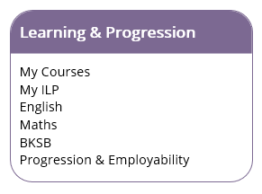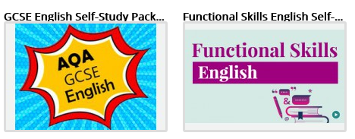



**BKSB**

Follow the steps below. To avoid any confusion around passwords, we have reset all students’ BKSB passwords to: **Password123%**.

**Student Username for BKSB**: Student ID Number

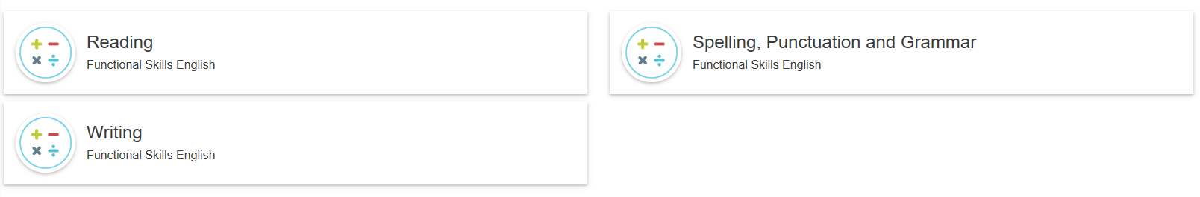

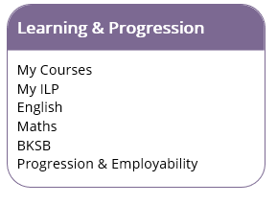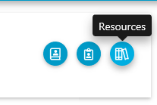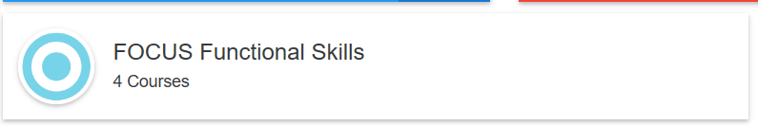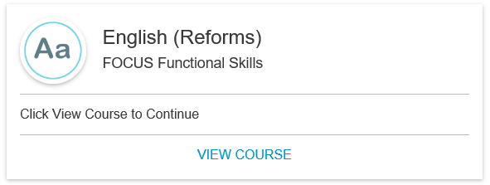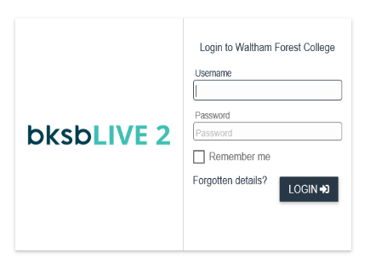

By following the steps above, you can access **level-specific resources** (including videos, texts, questionnaires etc) and complete **Skill Checks** to strengthen your learning/understanding.

**GCSEPod**

GCSEPod **(Student Quick Start Guide attached)** has created a pack of resources to help you prepare for your exams. Follow the steps below to access these resources (also uploaded to **Moodle**> **GCSE English Self-Study Pack**> **Teaching and Learning Resources**)

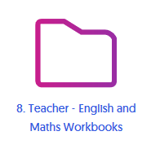

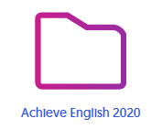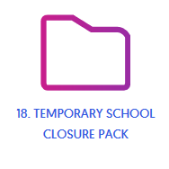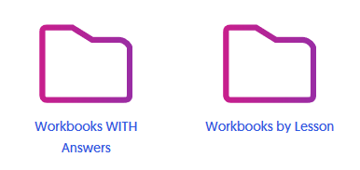

|  |  |
| --- | --- |
| **GCSEPod Login Information for Students:** |  |

Please use the link shown to access guidance on the above initiative. <https://www.youtube.com/watch?v=8g6a4e7NKNA&feature=youtu.be>

Kind regards,

**Omur Derelikoylu**Head of Department for English and Prince’s Trust **|**

cid:image001.png@01D5331F.57ADD330

cid:image002.png@01D5331F.57ADD330  020 8501 8163

cid:image003.png@01D5331F.57ADD330  [omur.derelikoylu@waltham.ac.uk](mailto:omur.derelikoylu@waltham.ac.uk)

cid:image004.png@01D5331F.57ADD330  [www.waltham.ac.uk](http://www.waltham.ac.uk/)

cid:image005.png@01D5331F.57ADD330  707 Forest Road, Walthamstow, London, E17 4JB